Writing task: Writing a comic
Suggested SPAG: Conjunctions

Task 1:
Think about a story that you would like to tell. This can be true or imaginary! Create a plan, including who are the characters, where is it set and what will happen. You could use the story mountain below to help you.

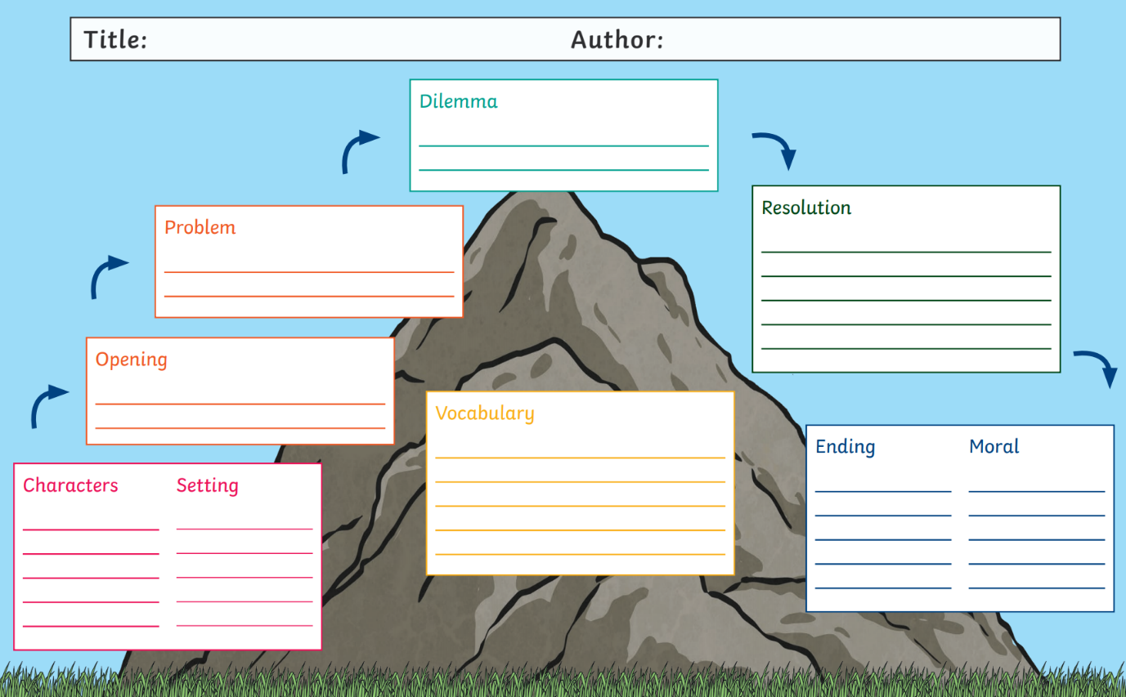

Task 2:
Now, it is time to set out your comic. Think about what you have seen before- how would you like it to look? Complete each picture section of your comic.

Task 3:
Add the writing to your comic. Try to use conjunctions to link events. You could even use time adverbials (Next, then), to help to describe what happens next.

