Week beginning 20/04/20
These tasks are activities to complete throughout the week. The idea is to complete one each day. It is not necessary to print the sheets as you could draw or write your answers on paper.
Please remember to practise times tables as often as possible making sure you are secure with the 2, 5 and 10 times tables before moving on to the 3, 4 and 8 times tables.

Activity 1- Place value- Counting in 4s, 8s, 50s and 100s
Work out what is being added on in each sequence to help you calculate the missing numbers.
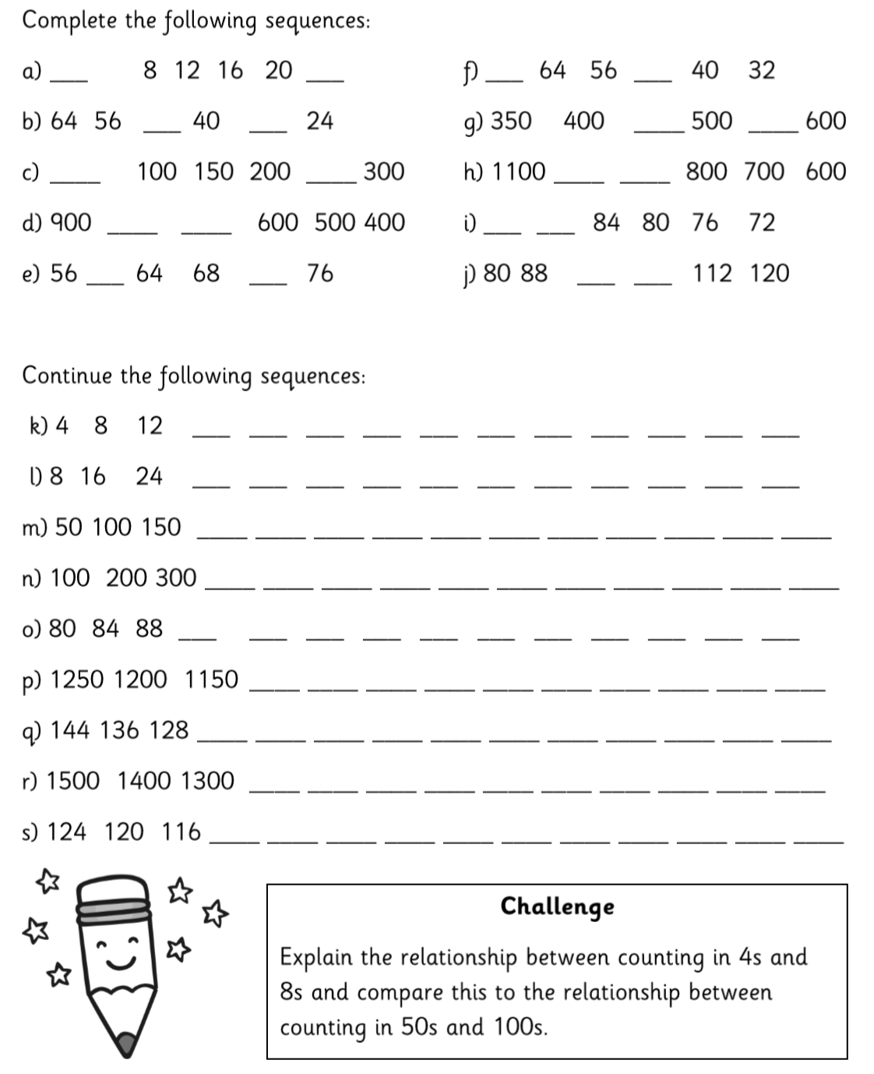

Activity 2- Addition and subtraction- Adding and subtracting ones to and from a 3-digit number
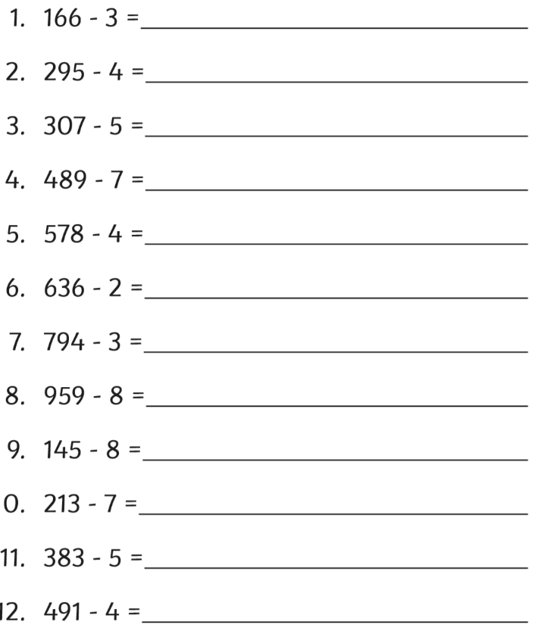
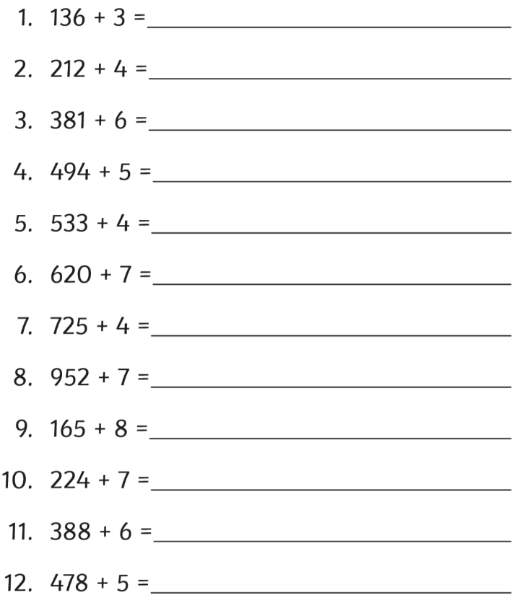

Challenge:
Explain how you would use 7 + 8 = 15 to calculate 537 + 8.
Explain how you would use 14 - 8 = 6 to calculate 384 - 8.

Activity 3- Multiplication- Multiplying by 3 and 4
Answer the calculations below and find the answers in the word search next to it.

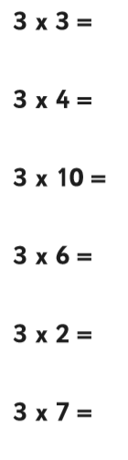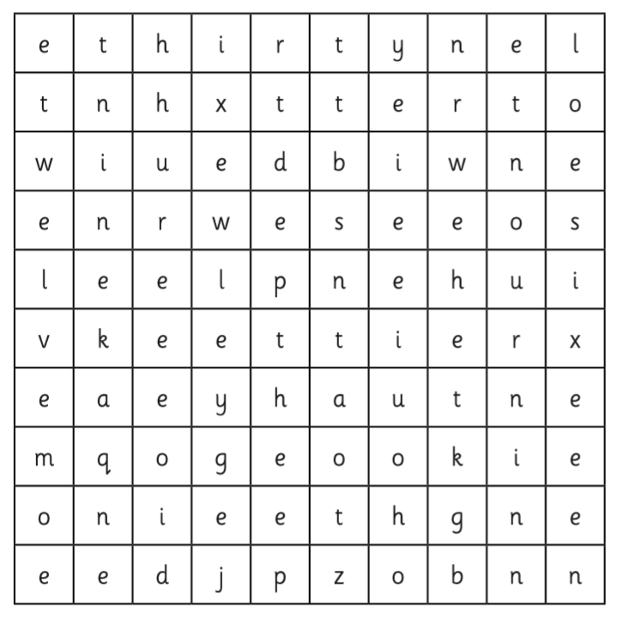
Challenge: Can you create your own questions and draw a word search for the eight times table?

Activity 4- Fractions- Counting up and down in tenths
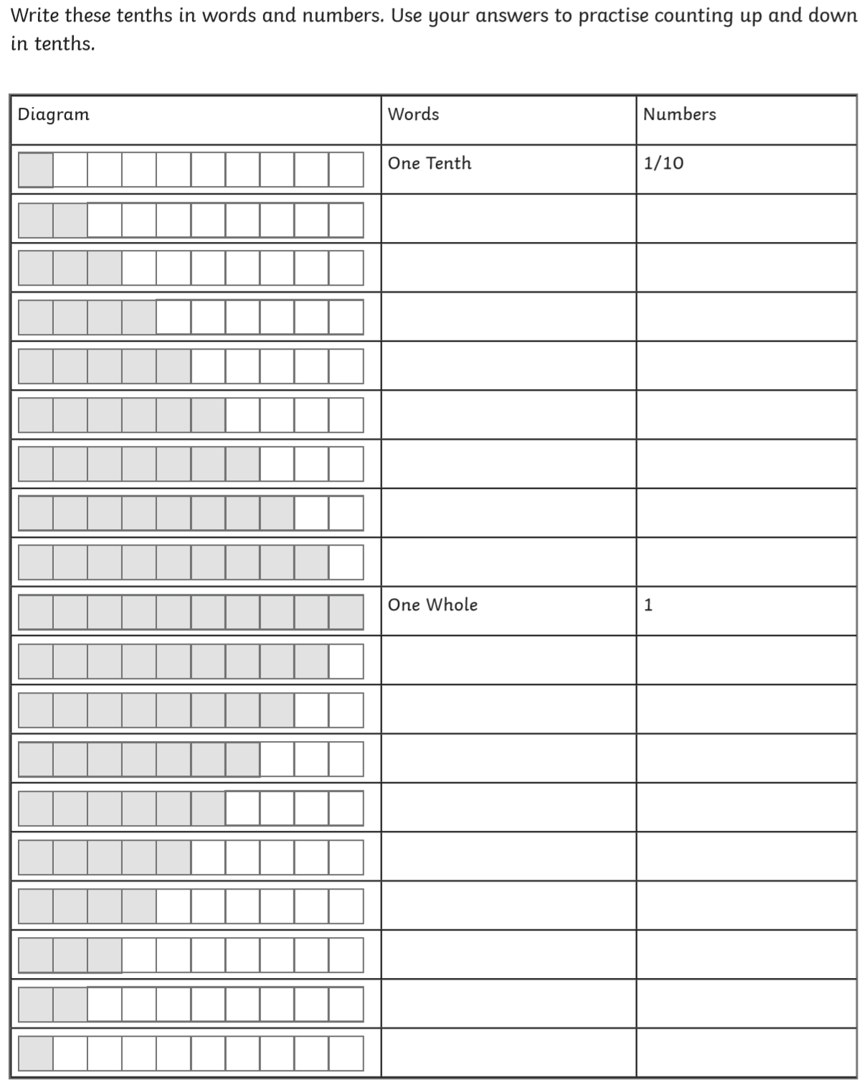
Challenge: Can you do the same for counting in fifths?
What do you notice about the relationship between counting in tenths and counting in fifths?

Activity 5- Shapes- Properties of 2D shapes
Remember: Vertices are the points where the edges join.
