21.09.2020
Stem:
Write the following numbers in numerals:
a) Five hundred and sixty two.
b) Six hundred and forty.
c) Nine hundred and three.

Write the following numbers in words:
a) 213
b) 305
c) 840.

Going deeper:
Complete the following:

358
Write the number in words.
The digit ___ is in the ones place.
The digit 3 stands for ___.
The value of the digit 5 is ____.

Now do the same with the numbers:
409
815

Deeper still:
A)

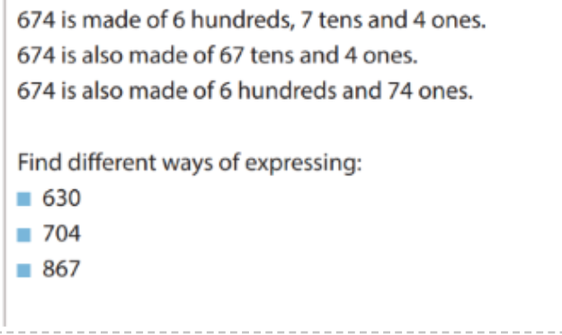

B)

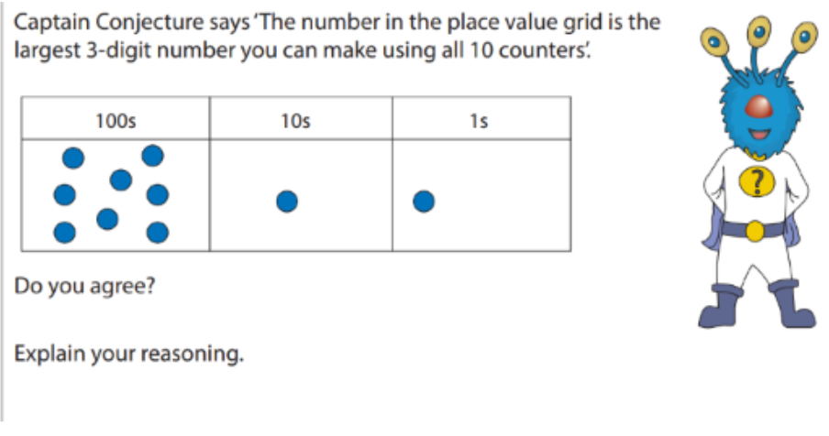

Hitting the Core:
A)
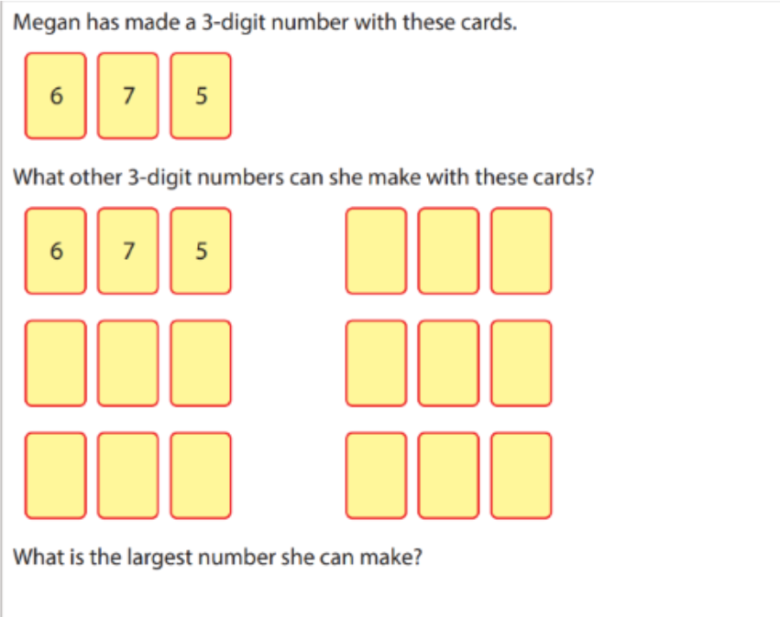

Word bank
- One, two, three, four, five, six, seven, eight, nine.
- Twenty, thirty, forty, fifty, sixty, seventy, eighty, ninety.
- Hundred.

