18.09.2020

Stem:

- Pick a number from the numbers below.
- Draw this number. Represent it using base ten.
- Partition the number and write it in words.

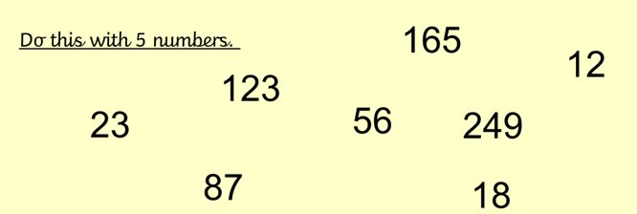

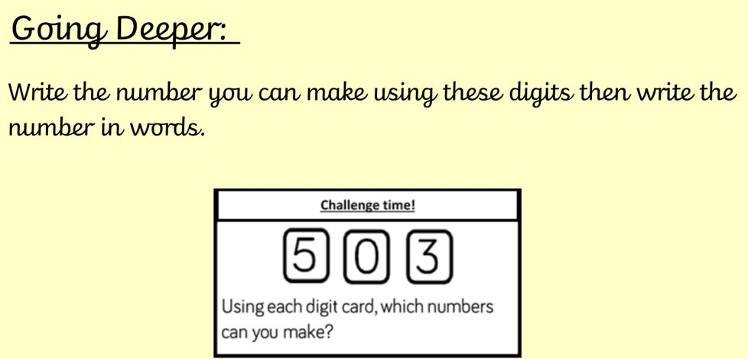

Deeper Still:

A) Find the answer then write the number in words and explain your answer using mathematical vocabulary.

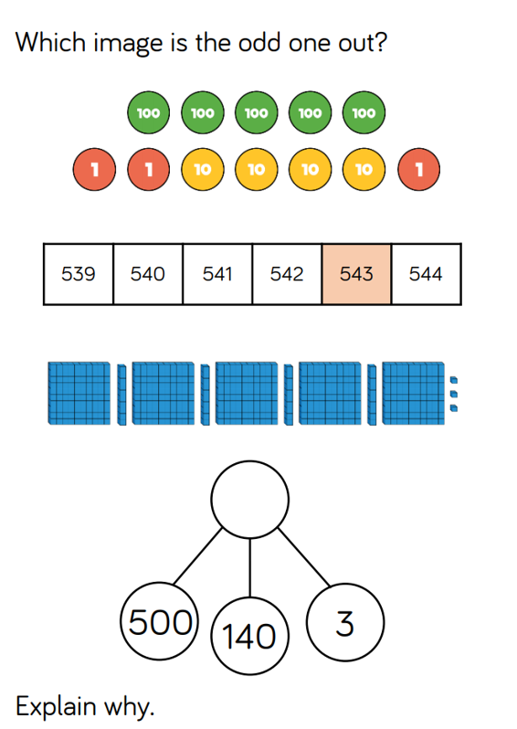

B) Find all possible answers and write them in numerals as well as words.

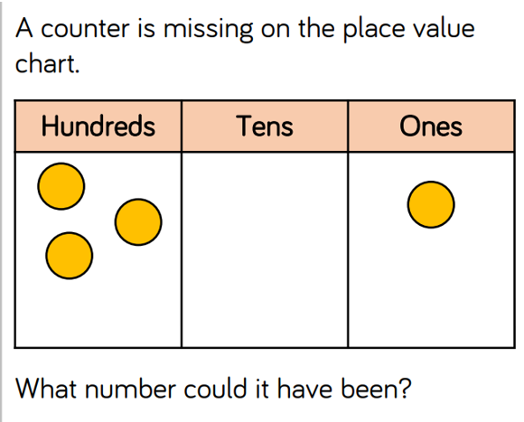

Word bank
- One, two, three, four, five, six, seven, eight, nine.
- Twenty, thirty, forty, fifty, sixty, seventy, eighty, ninety.
- Hundred.

