17.09.2020
Stem:
Represent the following numbers using a place value column chart and write down the value of the underlined digit, just like we have been doing.

- 26 b)

- 271

- 540
100
100
100
10
10
100
100
10
10

Going Deeper:
Explain the differences in the values of 6 in the following numbers:
368
607
56

Deeper still:

A) Josh says that the above representation is of the number 10031.
Is he correct? Explain.

B)

Dorrie says that the above representation is of the number 403.
Is she correct? Explain.

Hitting the Core:
A)
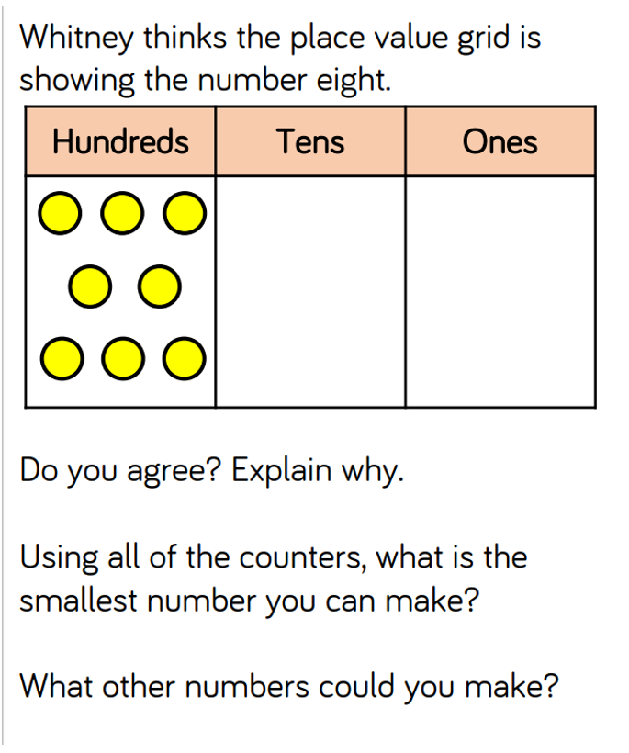
B)
