PAST TENSE
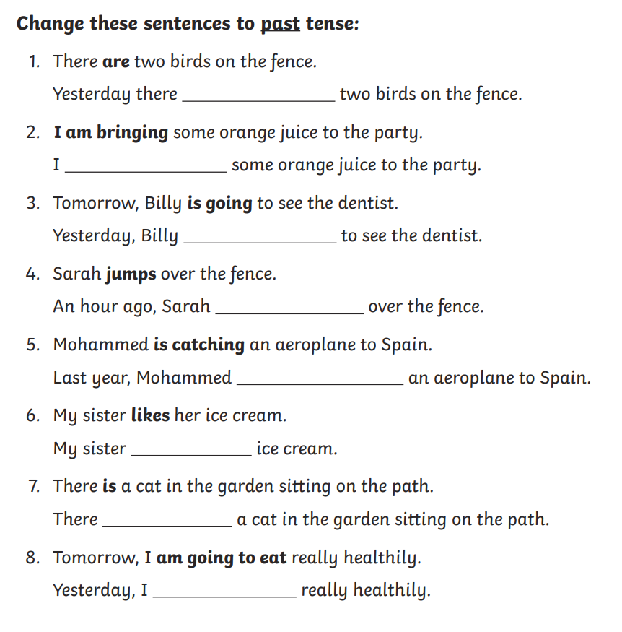

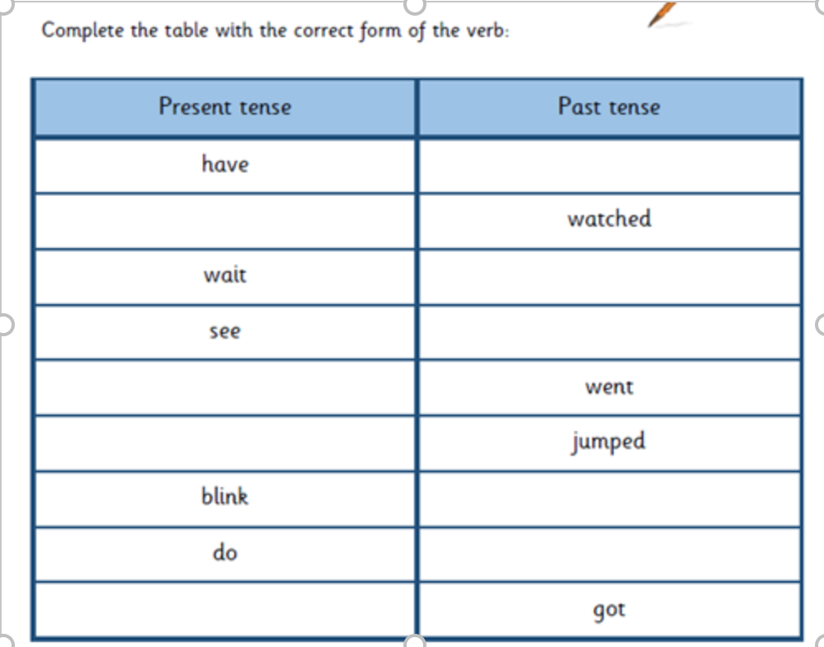

Find the verbs that aren’t in the past tense in the sentences below, highlight them then rewrite the sentence using the correct past tense.
Here’s an example for you:

Everyone sing happy birthday to me and I blow out the candles on my pretty pink cake.
Everyone sang happy birthday to me and I blew out the candles on my pretty pink cake.
1) When I ride my bike I hit a kerb and fall off, I break my leg so the ambulance come.
2) Not long after I wake up, I made myself some breakfast. I have some scrambled eggs on toast.
3) My dad take me fishing last Friday, I catch a big carp, he take a photo of me.
4) My Nanna teach me how to sew, with her help I make some beautiful clothes for my doll Lucy.
5) I forget to pick my brother up from work, so he caught the bus home and were 30 minutes late.

